Bikini Bottom – Sex-linked and Blood types Name: __________________________
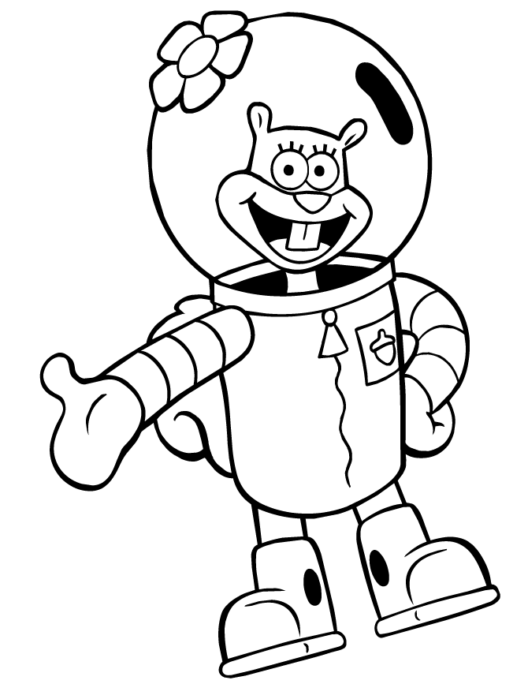
Use the notes taken in class to help you answer the following questions. Remember that blood types have multiple alleles (A, B, O) and sex-linked traits are associated with the X and Y chromosomes (the ones that determine gender).
Part A - Blood types
- Tell whether the following blood genotypes are homozygous (homo) or heterozygous (hetero).
AA ________ OO ________ BO __________ BB __________ AB __________ AO ______________
Which are purebred? ________________________ Which are hybrid? ____________________________
- Determine the blood type (phenotype) for each genotype:
AA = type _____ AO = type _____ OO = type _____ BB = type _____ BO = type _____ AB = type ______
- For each blood type (phenotype), give the genotypes possible:
Type A: ________ Type B: ________ Type O: ________ Type AB: _________

- Sandy the Squirrel met Stewart the Squirrel at the water chestnut festival. They fell in love. Sandy is blood type AB and Stewart is type O. Sandy Squirrel’s genotype: ________Stewart Squirrel’s genotype: _________
Make a Punnett square to show the possible blood genotypes of their children.
  - What is the probability of their offspring having blood type O? ________ out of _______ or ______ %
  - What is the probability of their offspring having blood type AB? ________ out of ______ or ______ %
  - What is the probability of their offspring having blood type A? _______ out of _____ or ______ %
  - What is the probability of their offspring having blood type B? _______ out of _______ or _______ %

- Pearl, the whale, had a horrible accident at cheerleading practice and needed a blood transfusion. So she needed to find out her possible blood type. Her dad, Mr.Krabbs is homozygous for blood type A and her mom is heterozygous for blood type B.
Mr. Krabbs’ genotype = _______
Mrs. Krabbs’ genotype = _______
Make a Punnett square to show Pearl’s possible blood type(s).
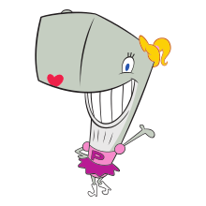
What is the possibility of Pearl having blood type O? _____ out of ____ or ______ %
What is the possibility of Pearl having blood type AB? _____ out of ____ or ______ %
What is the possibility of Pearl having blood type A? _____ out of ____ or ______ %
What is the possibility of Pearl having blood type B? _____ out of ____ or ______ %

Part B – Sex Linked Traits
- Tell whether or not the following carry or show the sex-linked recessive “krabby-blindness” trait. Also tell whether the individuals are male or female. Remember, “K” is healthy and “k” is krabby-blindness. Since this trait is sex-linked, you may have a situation in which only one allele is present. If the present allele is dominant (K), then the lack of another allele means the organism is healthy. If the present allele is recessive (k=blindness), then the lack of another allele means there is no way to cover or hide the blindness and it will show.
**Carrier = one who has only one of the affected alleles, but doesn’t usually show symptoms of the disorder.**
 | X^{K}X^{k} | X^{k}X^{k} | X^{K}Y | X^{K}X^{K} | X^{k}Y
Carrier? (yes/no)
Has the trait? (yes/no)
Male or Female

- Circle all of the following genotypes that show sex-inked traits: I^{A}I^{B}, X^{R}X^{R,} XrY, Hb^{A}Hb^{A}, X^{c}X^{c}

- How can a female inherit colorblindness?

- Fathers do not pass sex-linked traits to their sons. Why?

- Under what conditions is it possible for both a father and his son to have hemophilia (a sex-linked bleeding disorder)?

- Why are there more colorblind males than females?

- A krabby-blind whale has married Pearl, who has normal vision. One of their two sons is also colorblind. What are the genotypes of the parents?

- In Sandy Squirrel’s family her parents do not have hemophilia, but one of her brothers has hemophilia. Who was the carrier for hemophilia?
**Before you begin the problems, remember that you set up the problems with the mom’s and dad’s sex chromosomes, and then give them the appropriate superscripts, depending on their genotypes.**

- In sponges, there exists a sex-linked recessive disorder that causes a sponge to have tiny pores. (XN = normal pores, Xn = recessive small pores). SpongeBob and his true love, SpongeSusie, are planning to have baby sponges. SpongeBob has the disorder and Susie is a carrier.
SpongeBob’s genotype = ________
SpongeSusie’s genotype = ________
Make a Punnett square to show the possible genotypes of their children.
What percentage of their sons will have the disorder? _________
What percentage of their sons will be normal? _________
What percentage of their daughters will have the disorder? _________
What percentage of their daughters will be normal but be carriers? _________
What percentage of their daughters will be normal non-carriers? _________
- In squid, eye color is a sex-linked trait. Red eyes (R) are dominant over white eyes (r). Squidward (white eyes) has fallen head over heels for a red-eyed beauty, Squidonna. Squidonna also was smitten with Squidward as he was very different from her parents who both had red eyes and she would like to have white-eyed children.
Squidward’s genotype = _________
Squidonna’s genotype = _________

Make a Punnett square to show the possible genotype of their children.

What percentage of their sons will have white eyes? __________
What percentage of their sons will have red eyes? __________
What percentage of their daughters will have red eyes? __________
What percentage of their daughters will have white eyes but be carriers for the red-eyed trait? __________
What percentage of their daughters will be white-eyed non-carriers? __________

