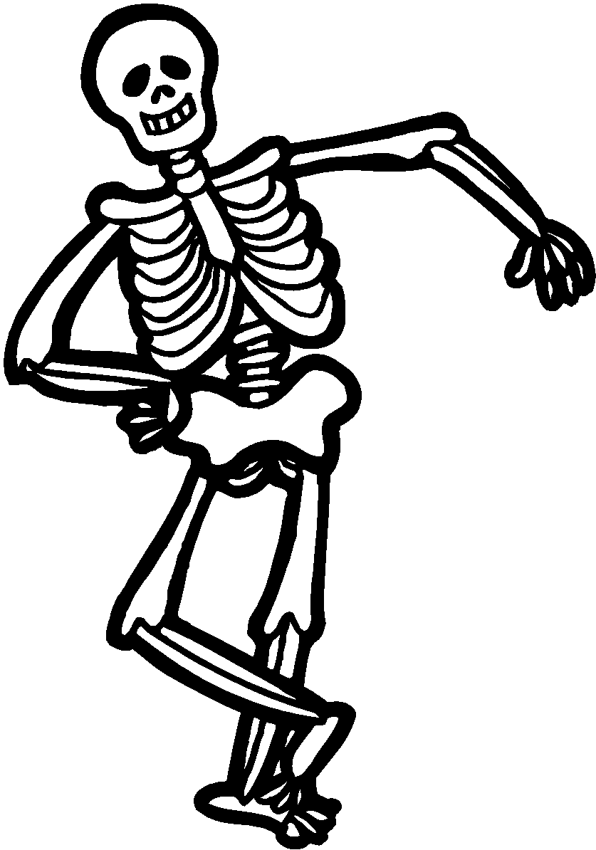
Skeletal System Notes Name: _______________

Date: ________________
Period / Team: _________
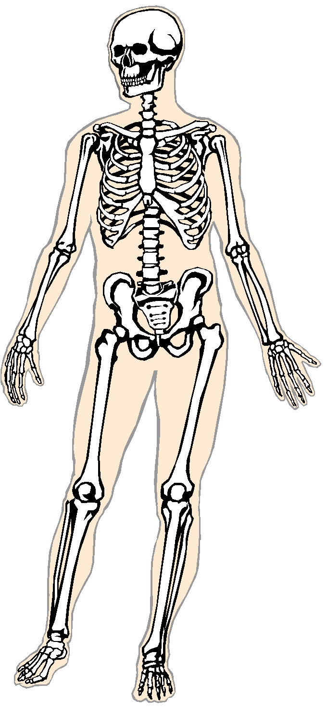
What are the main FUNCTIONS of a skeleton? (What does the skeleton do?)

- It gives us ___________________________________________________.
- It helps us _________________________.
- It protects our ______________________.
- It produces _____________________________________________.
- It stores stuff (like _____________ or ______________) until your body needs it.
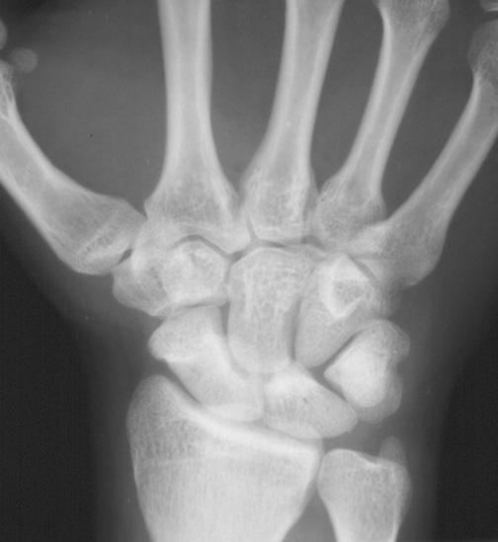
What is a JOINT? Why are JOINTS important?

- Bones are connected at ________________________.
- Joints allow bones to ____________ in different ways…or are _________________________

What are the different TYPES of Joints?

1) HINGE JOINT - ____________________ 2) BALL-AND-SOCKET JOINT - ________

__________________________ _______________________

__________________________ _______________________
_
Examples: ______________________ Examples: ________________________

3) PIVOT JOINT - ____________________ 4) GLIDING JOINT - ___________________

__________________________ _________________________

__________________________ _________________________

Examples: ______________________ Examples: _______________________

Are BONES alive?

The skeletal system, like all organ systems, is made of up _____________ (your bones), which are made up of living ____________________________________.
Bones ___________________________, and can ________ themselves if you break one!

Keeping Bones Healthy : ________________ and __________________________
- _______________________ is a disease where bones lose ____________________ and become ______________.
- Osteoporosis mostly affects the ___________________________________.

Muscular System Notes Name: ____________________
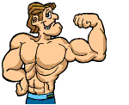
Date: _____________________
Period/Team: ________________

What is the Muscular System?
MUSCLES are: ____________________ that can ________________________________ to provide the _________________ needed to move your body parts.
TENDONS are: __________________________________ that attach _______________ to ______________ . (This connection allows your muscles to move your bones.)

What does your muscular system do? (What is its FUNCTION?)
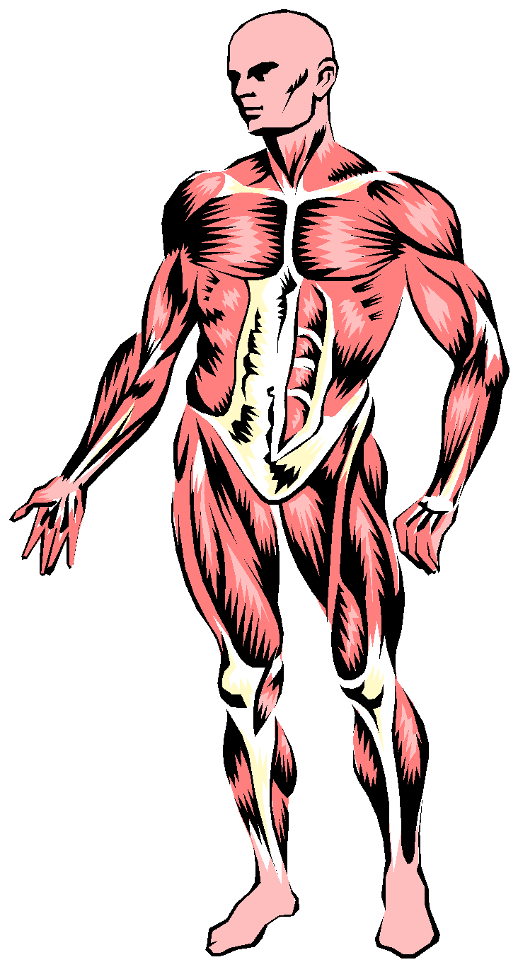

- It holds _______________ together so you can move.

- It holds our __________________ in place.

- It helps us _______________________________________ our food.

- It pumps our _____________________.

- It allows you to _____________, smile, _____________, laugh, etc.

What types of muscles are there?
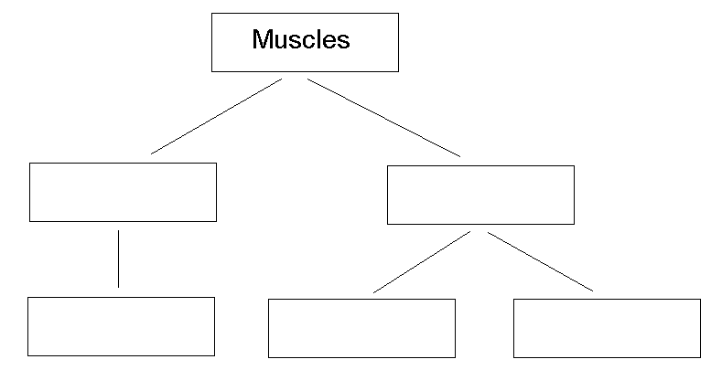

Muscles can be:
- _____________________ (you choose to use them) or ____________________ (they work without you thinking about them)
And, they can be:
- ___________________(attached to bones), __________________(in your digestive system), or ___________________ (in your heart)

How do muscles work?
Muscles __________________. They ___________________ (contract), and then ____________________ to return to original length.
Muscles often ________________________, so they can pull in __________________ or _______________________ directions.
Example: a) ______________ bends elbow b) _____________ extends elbow.

