Name: ______________________________

Protist: _______________________________...known for living as a colony

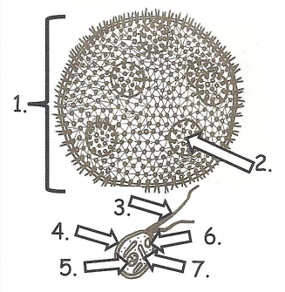

Movement (locomotion):

Reproduction:

Metabolism:

Label the parts

1. ________________
2. _________________
3. _________________
4. _________________
5. _________________
6. _________________
7. __________________

Protist: ___________________________...known for a “whip” tail or flagella

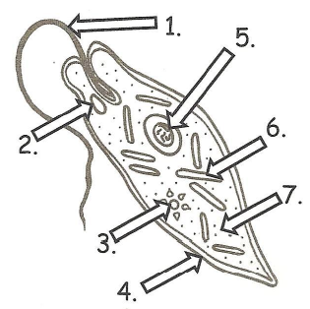

Movement (locomotion):

Reproduction:

Metabolism:

Label the parts

1. ________________
2. _________________
3. ________________
4. _________________
5. _________________
6. _________________
7. __________________

Name: ______________________________

Protist: _______________________________...known for “hair” or cilia to move

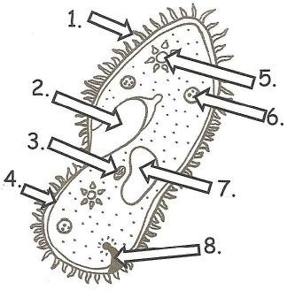

Movement (locomotion):

Reproduction:

Metabolism:

Label the parts

1. _________________
2. _________________
3. _________________
4. _________________
5. _________________
6. _________________
7. __________________
8. _________________

Protist: _______________________________...known for moving with fake feet or “blob-like” motion

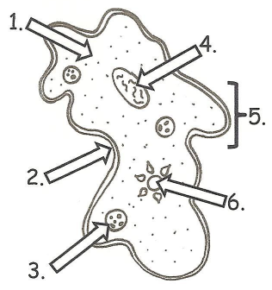

Movement (locomotion):

Reproduction:

Metabolism:

Label the parts

1. _________________
2. _________________
3. _________________
4. _________________
5. _________________
6. _________________