Net Force Practice Problems Name: __________________________
5 N - 2 N = 3 N
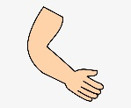
Period/Team: ____________________
Date: ___________________________
Remember, sometimes forces work together so you add them. If forces work against each other, you subtract them. The NET FORCE is the overall force that is left after you have done that adding or subtracting. For example, if I pull the candy with 2 N of force towards me and the baby pulls the candy with 5 N of force towards her, my force will cancel out 2 N of her force…but there will still be an overall or NET force of 3 N of force towards the baby.
Show the net force (and direction of that force) for each problem.
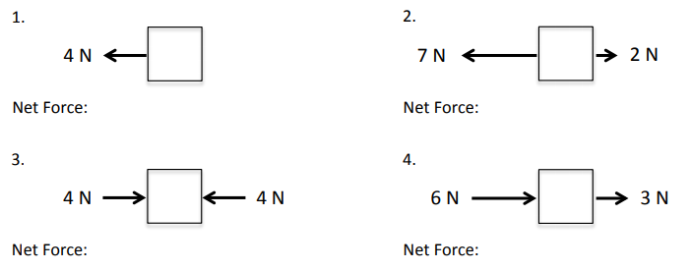
4N + 0N = 4N
NET FORCE = 4N left or 4N
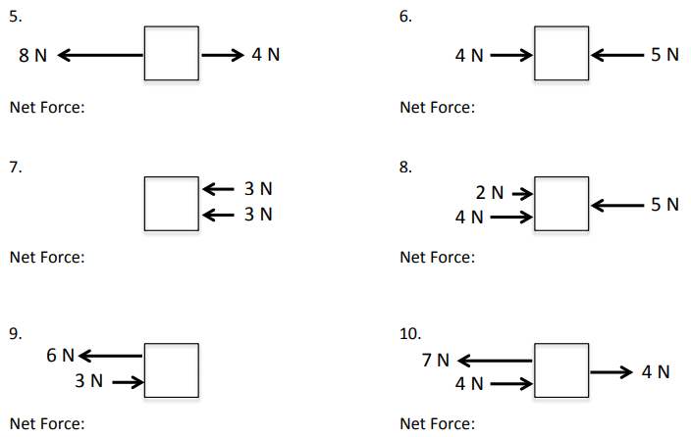
11. What is net force? Explain it in YOUR words, but be clear. _________________________________________________________________________________________________ ____________________________________________________________________________________________________________________________________________________________________________________________________

Show your work for problems 12-14. Draw a picture; show your equation; give your final answer with direction.
12. A boy pulls a wagon with a force of 6 N East as another boy pushes it with a force of 4N east. What is the net force?

13. Mrs.Kidwell and her husband were trying to move their new chair. Mr. Kidwell pulls with a force of 30 N while Mrs.Kidwell pushes with a force of 25 N in the same direction. What is the net force?

14. The teams are playing tug of war. The Hornets pull with a force of 50 N. The Knights pull with a force of 45 N in the opposite direction. What is the net force? And who won?

15. What is a balanced force? __________________________________________________________________________________________________ __________________________________________________________________________________________________
16. What is an unbalanced force?
__________________________________________________________________________________________________ __________________________________________________________________________________________________

17. Draw a picture below that shows an example of a balanced force (examples: a bird’s nest in a tree, a hat on a person’s head, or a light hanging from a ceiling). Show the forces acting on the object. In a separate picture, show what would happen to the object if the forces became unbalanced. Label them as “Balanced” or “Unbalanced” and show the forces.

