The Nervous System Name: _________________________
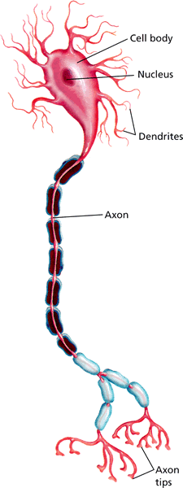
What is its FUNCTION? Period/Team: ____________________
- _______________________ about what’s happening ______________ and _____________ the body.
- _______________ the way your ____________ to this info.

- Helps maintain _________________.

The nervous system is made up of the:
- _____________________________
- _____________________________
- _________________________ that branch out to ALL parts of your body

What is a NEURON?
__________________________ through the nervous system.
There are ____________________ of neurons in your body.
They are constantly ________________________________ _____________________________.
The message that a neuron carries is a __________________________________.
Use the illustration and show the direction of the impulse flow.
____________________ = receives messages and sends them toward _________________________________________.
____________________ = carries the message down to the ___________________________ , which sends the message to the next neuron.
What is a synapse? Explain it in YOUR words.
__________________________________________________________________________________________________________________________________________________________________________________________________________________________________________

Do You Know It? Name: _________________________
Endocrine System (and immune system) Period / team: __________________
Label the parts.
In the brain:
- ______________________________________________
- ______________________________________________
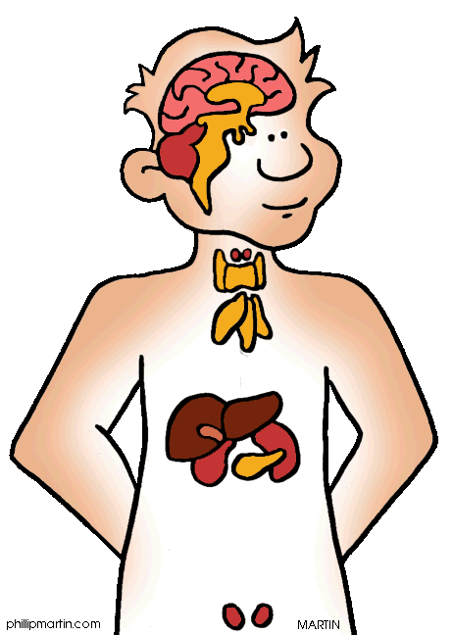
In the neck/chest:
- ______________________________________________
- ______________________________________________
- ______________________________________________
In the main body/trunk area:
- ______________________________________________
- ______________________________________________
For girls: I.______________________________________________

For boys: H.______________________

What is the function of the endocrine system? _____________________________________________________________________________ _____________________________________________________________________________
How is it different than the nervous system? _____________________________________________________________________________ _____________________________________________________________________________
What does it have in common with the immune system? _____________________________________________________________________________ _____________________________________________________________________________

