MCj01052040000[1]MCj01052060000[1]

**INTRODUCTION TO**  Name:___________   
 Date: ___________  
 Period/team: ___________  
  
  
  
  
A **FORCE** is a: ________________ or _______________ in a particular __________________.  
  
 *Forces affect how objects move.*  
  
 Forces can affect motion in the following ways:  
   
 BIG i)  
  
 SCIENCE ii)  
  
 IDEA! iii)  
  
 iv)  
  
 v)  
  
 vi)  
  
* Since forces cause changes in speed or direction of an object, we can say that   
  
forces change _________________, so…… FORCES cause __________________ !  
  
More than one force can act on an object at one time. What happens to the object when forces act depends on 2 things:  
  
 1)  
  
 2)  
  
When more than one force acts on an object, the forces _______________   
  
to form a _________________________________.  
  
Forces may _____________________ or _______________________.  
  
If the effects of the forces **cancel each other out**, and do not cause an object to   
  
move, the forces are said to be _______________________.  
  
If the forces **don’t cancel each other out** – 1 force is stronger than the others –   
  
the forces are _________________ and will cause a _______________________.

**FORCE**

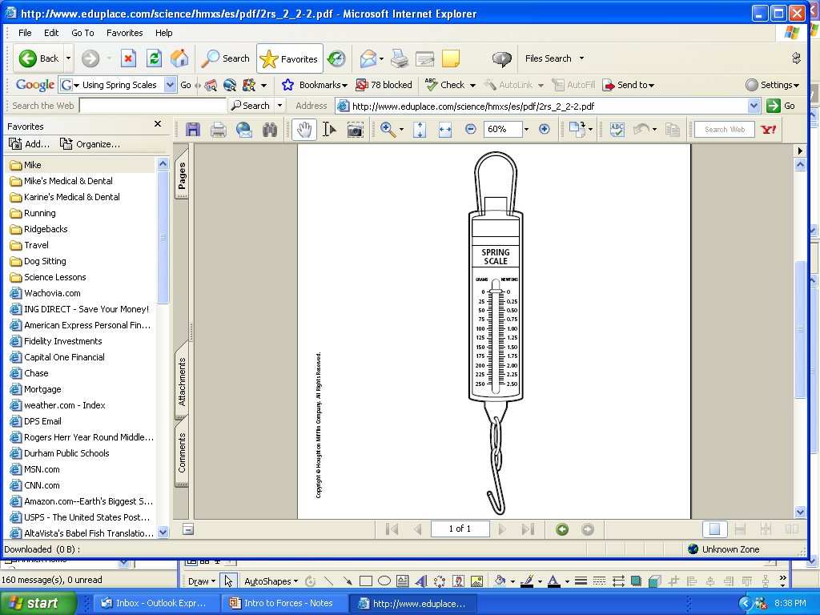  
**MEASURING FORCE**The strength of a force is measured in _____________ .   
  
The symbol is ______.   
  
We can use a ___________________________ to measure   
forces in our science experiments.   
  
**COMBINING FORCES**Two forces ____________________ can _____ together to produce a LARGER net force.

______ _____ _____  
  
  
Two forces ____________________ can ___________ to produce a SMALLER net force in the direction of the larger force.  
  
  
  
 ______ _____ _____  
  
  
Two forces may ______________________________ and produce NO NET FORCE.  
  
  
  
  
 ______ _____ _____  
  
  
Some examples of forces are:

= 0

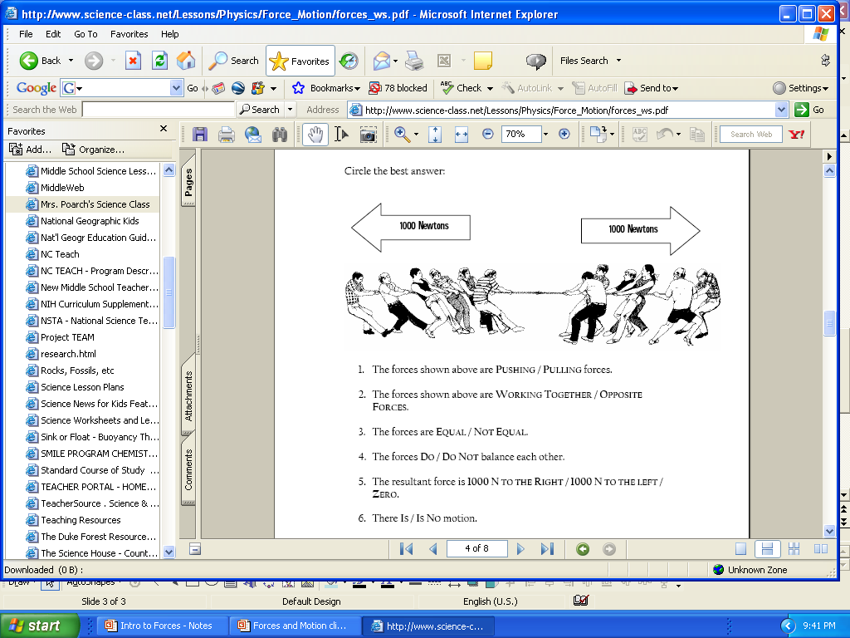

Circle the best answer:

1. The forces shown above are PUSHING / PULLING forces.
2. The forces shown above are WORKING TOGETHER / OPPOSITE FORCES.
3. The forces shown above are EQUAL / NOT EQUAL.
4. The forces DO / DO NOT balance each other.
5. The net force is 1000 N TO THE RIGHT / 1000 N TO THE LEFT / ZERO.
6. There IS / IS NO motion.

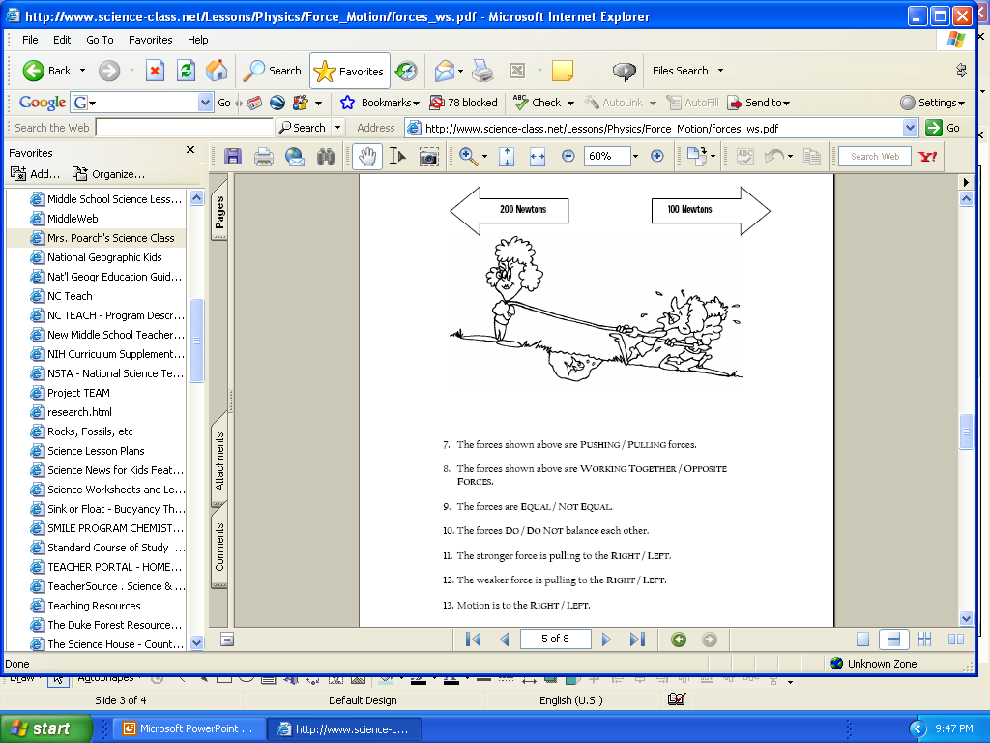

Circle the best answer:

1. The forces shown are PUSHING / PULLING forces.
2. The forces shown are WORKING TOGETHER / OPPOSITE FORCES.
3. The forces shown above are EQUAL / NOT EQUAL.
4. The forces DO / DO NOT balance each other.
5. The stronger force is pulling RIGHT / LEFT.
6. Motion is the to the RIGHT / LEFT.

1. Two movers are trying to move a heavy box. One mover pushes to the right with a force of 150 N. The other mover pushes to the left with a force of 200 N.

a) Draw & label the forces on the diagram.

b) What is the net force? _______________

c) Will the box move? __________________

If yes, in what direction? _______________

If no, why not? _______________________

1. Two movers are trying to move a heavy chair. One mover PULLS to the left with a force of 200 N. The other mover PUSHES to the left with a force of 200 N.

a) Draw & label the forces on the diagram.

b) What is the net force? _______________

c) Will the chair move? _________________

If yes, in what direction? ________________

If no, why not? ________________________

1. Four children are fighting over the same toy. Mike is pulling North with a 50 N force, Justin is pulling East with a 40 N force, Chantal is pulling South with a 50 N force, and Tykera is pulling West a 30 N force.

a) Draw & label the forces on the diagram.

b) Is there a net force on the toy? ____________

c) In which direction will the toy move? ________

d) Who gets the toy? _______________________

MCj03227410000[1]MCj03833820000[1]

